FoneBook

Development Guide
Contents

Getting Started 2
Development Prerequisites 2
Architecture 2
Current Fonebook Environments 3
Development 3
Clone Source Code 4
Client Side Development 5
Server Side Development 5
Local Database 6
Push Code to Bitbucket 6
New Instance Setup 7
DNS Entry 7
Add Subdomain 8
Server Setup 8
Server Connection 8
Install Software 9
Configure YUM Repositories 9
Install Additional Software 10
Edit Hostname 10
Add Security/Firewall 10
Add Users 11
Performance Tuning 11
Configure Nginx 12
Create Certificates 14
Enable MongoDB: 14
Addition Security and Sudo Access 15
Enable Server-Side Application on Boot 15
Enable Certificate Renewal 15
Configure Backups 16
Application Deployment 16
Client Side 16
Server Side 16
Database 16

Getting Started

Development Prerequisites
In order to do any development on Fonebook the following software should be installed on the computer where development will be done.

- Node.js (https://nodejs.org/en/) *Always install the LTS version
- Git (https://git-scm.com/)
- Visual Studio Code (https://code.visualstudio.com/)
- Go (https://golang.org/)
- MongoDB Community Server (https://www.mongodb.com/download-center/community)
- MongoDB Compass (https://www.mongodb.com/products/compass)

After all the prerequisites have been successfully installed you need to create the required folders to use Go. To create these folders the steps below can be followed

- Open Run from the windows menu
- Enter %userprofile% and click OK
- Enter the go folder
- Create 3 folders
  - bin
  - pkg
  - src
- Open the src folder
- Create a folder main

If you prefer doing it with command prompt
- Open Command Prompt
- Run the following commands
  - mkdir %userprofile%\go\bin
  - mkdir %userprofile%\go\pkg
  - mkdir %userprofile%\go\src
  - mkdir %userprofile%\go\src\main

Architecture
Fonebook was developed using ReactJS for the client side application, Go Language as a RestAPI Server Application and MongoDB for the database. The client application, server side application and database is hosted on a Linux VM.

Each client using Fonebook has their own Linux VM with their own subdomain under the main domain sabco.za.com.

The source code is stored in a Bitbucket Git repository. This is important as the version control allows you to revert changes if needed.

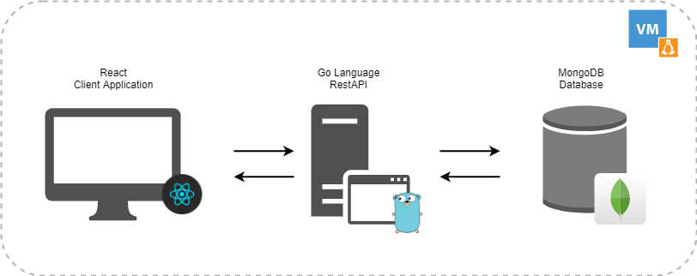

Current Fonebook Environments
There are currently 3 Linux VM servers running. The setups are identical with different domains and code bases.

Client | Domain | IP Address | Bitbucket Repo
Adrian’s Call Centre | fonebook.sabco.za.com | 154.66.196.101 | Fonebook
Cell C | collections.sabco.za.com | 154.66.196.71 | FonebookCollections
EOH | eohcollections.sabco.za.com | 154.66.196.103 | FonebookEOHCollections

Host: https://www.domains.co.za/
OS: CentOS7
SFTP: Yes (Port 22)
Front-End App Location: /usr/share/nginx/html/fonebook (Hosted with NGINX)
Back-End API Location: /opt/apps/fonebook
Username: appuser
Password: P@$Sbg0mb2dIgt3^lsD1

Development
Once all the development prerequisites have been installed you can start making code changes. If you are not familiar with the technologies mentioned in the architecture I recommend familiarizing yourself with these before attempting to make code changes. Below are a few useful links to get you started

React
- https://reactjs.org/tutorial/tutorial.html
- https://www.youtube.com/watch?v=dGcsHMXbSOA

Go Lang
- https://www.youtube.com/watch?v=ty49_v1tV44

MongoDB:
- https://www.youtube.com/watch?v=tXoTd7TH9K8

Git:
- https://www.youtube.com/watch?v=SWYqp7iY_Tc

Clone Source Code
To clone the source code to the development machine follow the next steps

- Create a folder Source on your C:\ drive
- Login to https://bitbucket.org/
- Go to Repositories and click on the repository that you want to clone
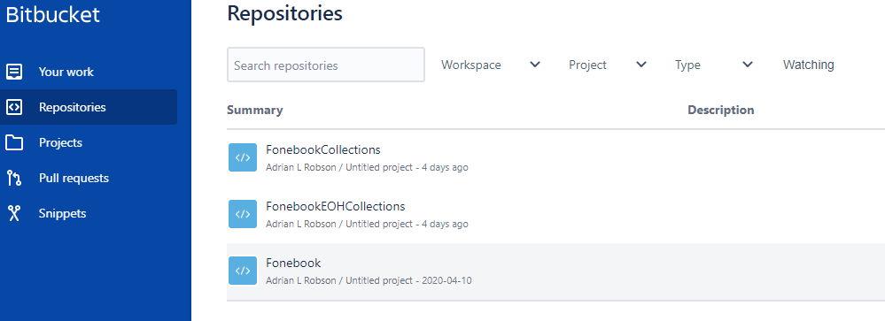

- Click on Clone
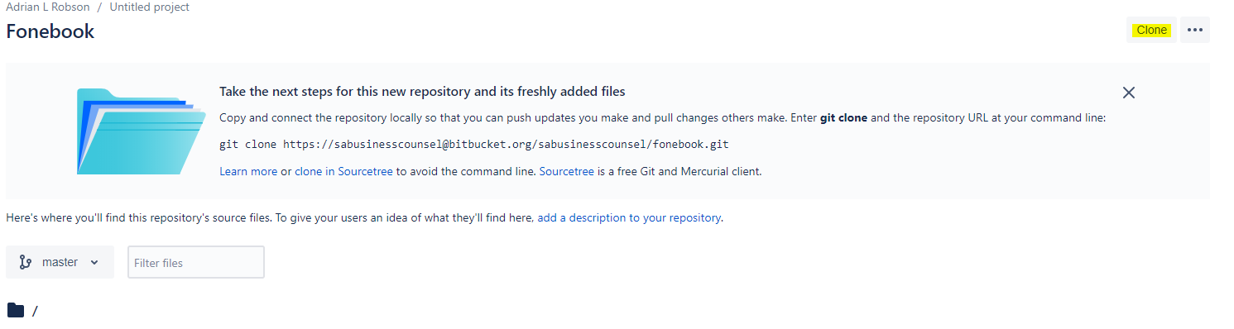

- Copy the clone link
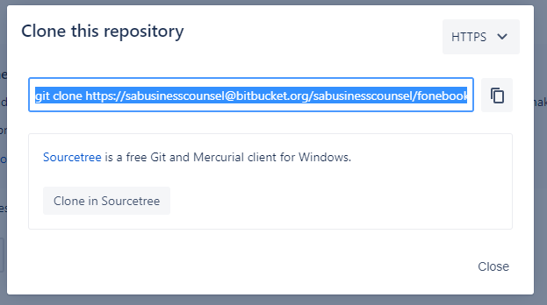

- Open Command Prompt and navigate to C:\Source using command cd c:\source
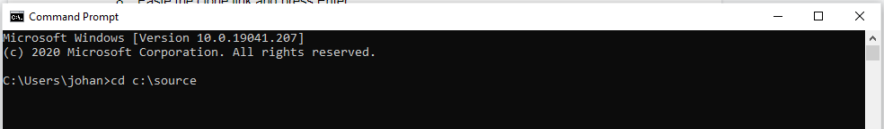

- Paste the clone link and press Enter
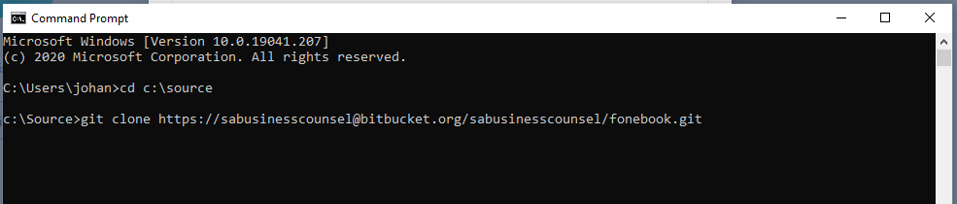

Once the clone is complete you have the code on your computer and can start development.

Client Side Development
To start client side development follow the steps below

- Open Visual Studio Code
- Click on File > Open Folder > Navigate to C:\Source\<project you want to work on>\client and click on Select Folder
- Click on Terminal > New Terminal
- If it is the first time you are developing on the project you need to install packages. In the terminal execute the command npm install
- Open the appsettings.js file in the src folder and be aware of the endpoint that the application is pointing to. If it points to a sabco.za.com url it will affect customer data. If it points to localhost ensure that you have the server running on you local environment.
- To start the application in the development environment, execute the following command in the terminal npm start
- If the application has started you can open your browser and navigate to localhost:3000
- React allows hot reloading, this means that you can make changes while the application is running and it will automatically reload once you save the changes.

All styling is done using the MDBootstrap (https://mdbootstrap.com/docs/react/). This site can be referenced for components and styling. IMPORTANT: always make sure that you reference the React documentation on MDBootstrap.

When all development is done and code is working as expected the changes need to be saved to the Bucket code repository. See Push Code to Bitbucket

Server Side Development
To start client side development follow the steps below

- Ensure that your local mongo database is running
  - Open Run
  - Enter services.msc and click OK
  - Scroll to MongoDB Server
  - Ensure that it is running
- Open Visual Studio Code
- Click on File > Open Folder > Navigate to C:\Source\<project you want to work on>\server and click on Select Folder
- You can now make any changes to the code.
- To run the application locally after making any changes click on Terminal > New Terminal and execute the command run.bat

NOTE: Go does not support hot reloading so the application has to be restarted after making any changes.

When all development is done and code is working as expected the changes need to be saved to the Bucket code repository. See Push Code to Bitbucket

Local Database
To setup your local database follow the steps below

- Ensure that your local mongo database is running
  - Open Run
  - Enter services.msc and click OK
  - Scroll to MongoDB Server
  - Ensure that it is running
- Open MongoDB Compass
- Click on Connect. Do not change any connection information
- Create a database with the name fonebook
- Create the following collections within the database
  - auth
  - clients
  - config
  - stores
  - tickets

Push Code to Bitbucket
To push the code to the Bitbucket repository follow the steps below.
- Have the project loaded as explained in Client Side Development and Server Side Development.
- Click on the source control tab to see all changes that have not been committed. Right click and Stage the files that you would like to commit.
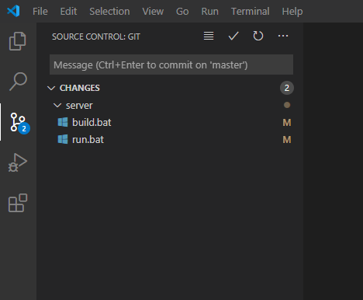

- Enter a commit message and click the commit check mark
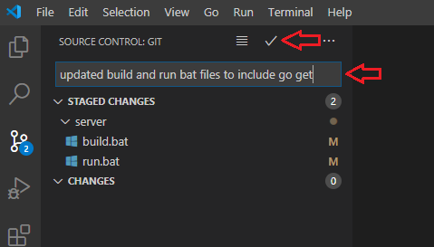

- Click on the sync button at the bottom to push the changes to Bitbucket
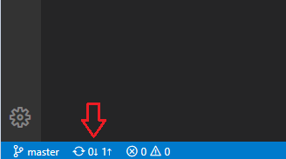

New Instance Setup
In order to set up a new environment for a client you will need to buy a new cloud server with, at minimum, the specifications below.

Operating System: CentOS 7
Memory: 1 GB
Hard Drive: 20 GB SSD
CPU: 1 Core Processor

Once the server is ready from the hosting company you should complete the setup as soon as possible to prevent it from being hacked and taken over. If it gets taken over by some hacker, you can simply reset the server then do the setup.

DNS Entry
In order to assign a domain to the server you need to add a dns entry for the server. Since fonebook mainly uses subdomains to access different instances the DNS entry needs to be made under the main domain. To add the DNS entry, follow the steps below

- Login into Office 365 admin portal (https://portal.office.com/Adminportal/)
- Go to Settings > Domains
- Click on sabco.za.com and click New custom record
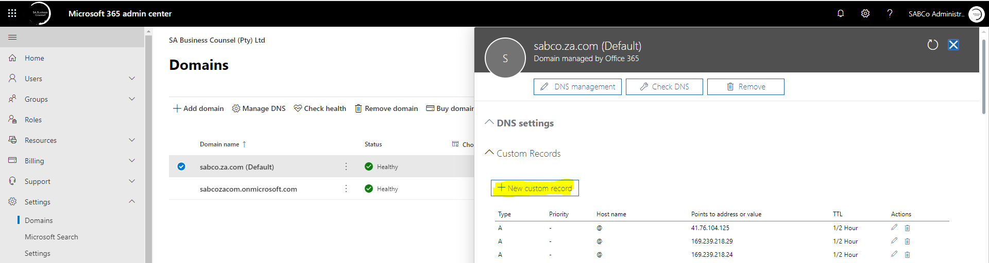

- Add the new DNS Entry
  - DNS Type: A / Address
  - Host Name: The new subdomain i.e. If the new subdomain is newcollection.sabco.za.com the hostname is newcollection
  - Click Save

Add Subdomain
The new server should be allocated it own domain. All fonebook instances runs on subdomains of sabco.za.com. To add a new subdomain, follow the steps below

- Login to domain.co.za
- Navigate to Manage Account > Web Hosting
- Click on the Manage button on the sabco.za.com entry
- Click on the CPanel Login button
- Click on Subdomains and add the new subdomain i.e. newcollection.sabco.za.com
- Manage the redirection for the new subdomain to redirect to https i.e https://newcollection.sabco.za.com

Server Setup

Server Connection
To connect to the server ensure that you have install PuTTY (https://putty.org/). If PuTTY is installed follow the steps below

- Open PuTTY
- In the category list navigate to Connection > SSH > Tunnels
- Set source port to 27017 and destination to localhost:27017 and click Add (This is to connect to the database later)
- In the category list navigate to Session
- Add the new server IP into the Host Name field
- Add a new server name to the Saved Sessions field and click Save
- Connect to the server by double clicking on the server name in the Saved Sessions list
- Login with root user

NOTE: When logging into the server the password enter will not show any characters in the terminal. Just enter the password and press Enter

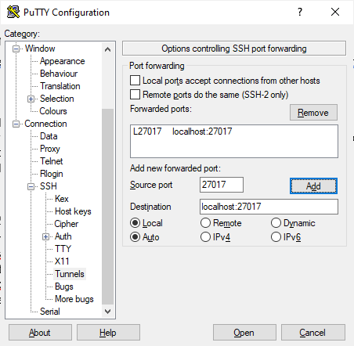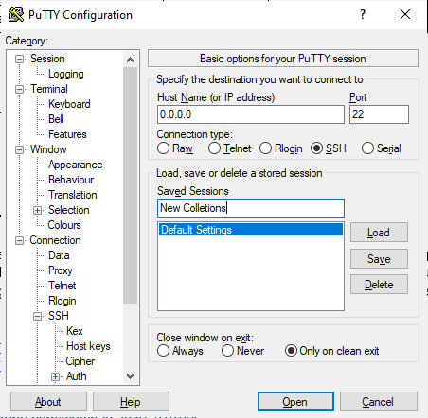

Install Software
Once you have logged into the server you will be required to install some software. To install the software run the commands below

- yum -y install vim
- yum -y groupinstall "Development Tools"
- yum -y install iptables-services
- yum -y install epel-release
- yum -y install net-tools
- yum update
- reboot

Configure YUM Repositories

Nginx
- Run command cd /etc/yum.repos.d/
- Run command vim nginx.repo
- Edit the file
  - Press the i button to enter insert mode
  - Paste the following content in the file
[nginx]
name=nginx repo
baseurl=https://nginx.org/packages/rhel/7/$basearch/
gpgcheck=0
enabled=1
  - Press the Esc button to enter escape mode
  - Type !wq and press Enter to save and exit

Install Additional Software
- Run command yum -y install yum-utils
- Run command yum -y install nginx
- Run command yum -y install certbot python2-certbot-nginx
  - Go here: https://certbot.eff.org/lets-encrypt/centos6-nginx

Edit Hostname
- Run command vim /etc/resolv.conf
- Edit the file
  - Press the i button to enter insert mode
  - Paste the following content in the file above the nameservers part
domain thesystem.co.za
  - Press the Esc button to enter escape mode
  - Type wq! and press Enter to save and exit
- Run command vim /etc/hostname
- Edit the file
  - Press the i button to enter insert mode
  - Enter the new subdomain name i.e. newcollections
  - Press the Esc button to enter escape mode
  - Type wq! and press Enter to save and exit

Add Security/Firewall
The steps below will add config for the firewall and only allow ports 22, 80, 443 accessible from the outside. Ports 12345 (Server-Side Application) and port 27017 (MongoDB) are only available on localhost.

- Run command vim /etc/sysconfig/iptables
- Edit the file
  - Press the i button to enter insert mode
  - Paste the following content in the file
# sample configuration for iptables service
# you can edit this manually or use system-config-firewall
# please do not ask us to add additional ports/services to this default configuration
*filter
:INPUT ACCEPT [0:0]
:FORWARD ACCEPT [0:0]
:OUTPUT ACCEPT [0:0]
-A INPUT -m state --state RELATED,ESTABLISHED -j ACCEPT
-A INPUT -p icmp -j ACCEPT
-A INPUT -i lo -j ACCEPT
-A INPUT -p tcp -m state --state NEW -m tcp --dport 22 -j ACCEPT
-A INPUT -p tcp -m state --state NEW -m tcp --dport 80 -j ACCEPT
-A INPUT -p tcp -m state --state NEW -m tcp --dport 443 -j ACCEPT
-A INPUT -p tcp -s localhost --dport 3306 -j ACCEPT
-A INPUT -p tcp -s localhost --dport 8081 -j ACCEPT
-A INPUT -p tcp --dport 8081 -j DROP
-A INPUT -j REJECT --reject-with icmp-host-prohibited
-A FORWARD -j REJECT --reject-with icmp-host-prohibited
COMMIT
  - Press the Esc button to enter escape mode
  - Type wq! and press Enter to save and exit
- Run command vim /etc/sysconfig/ip6tables
- Edit the file
  - Press the i button to enter insert mode
  - Paste the following content in the file
# sample configuration for ip6tables service
# you can edit this manually or use system-config-firewall
# please do not ask us to add additional ports/services to this default configuration
*filter
:INPUT ACCEPT [0:0]
:FORWARD ACCEPT [0:0]
:OUTPUT ACCEPT [0:0]
-A INPUT -m state --state RELATED,ESTABLISHED -j ACCEPT
-A INPUT -p ipv6-icmp -j ACCEPT
-A INPUT -i lo -j ACCEPT
-A INPUT -p tcp -m state --state NEW -m tcp --dport 22 -j ACCEPT
-A INPUT -p tcp -m state --state NEW -m tcp --dport 80 -j ACCEPT
-A INPUT -p tcp -m state --state NEW -m tcp --dport 443 -j ACCEPT
-A INPUT -p tcp -s localhost --dport 3306 -j ACCEPT
-A INPUT -p tcp -s localhost --dport 8081 -j ACCEPT
-A INPUT -p tcp --dport 8081 -j DROP
-A INPUT -j REJECT --reject-with icmp6-adm-prohibited
-A FORWARD -j REJECT --reject-with icmp6-adm-prohibited
COMMIT
  - Press the Esc button to enter escape mode
  - Type !wq and press Enter to save and exit

To enable the firewall to start at boot and start it now
- Run command systemctl enable iptables
- Run command systemctl enable ip6tables
- Run command systemctl restart iptables
- Run command systemctl restart ip6tables

Add Users

Adrian – Sudo User
- Run command useradd -m -d /home/darryll -s /bin/bash adrian
- Run command passwd adrian
- Enter a strong password i.e. snyu^Qq%CL*5ln#*e5yH

Application User
- Run command useradd -m -d /home/appuser -s /bin/bash appuser
- passwd appuser
- Enter this password: P@$Sbg0mb2dIgt3^lsD1 (this is for conformity across all instances)

Performance Tuning
- Run command vim /etc/sysctl.conf
- Edit the file
  - Press the i button to enter insert mode
  - Add fs.file-max=200000 to the file
  - Press the Esc button to enter escape mode
  - Type wq! and press Enter to save and exit
- Run command vim /etc/security/limits.conf
- Edit the file
  - Press the i button to enter insert mode
  - Paste the below at the bottom of the file
appuser soft nofile 65535
appuser hard nofile 68535
appuser soft nproc 65535
appuser hard nproc 68535

mongod soft nofile 65535
mongod hard nofile 68535
mongod soft nproc 65535
mongod hard nproc 68535

nginx soft nofile 65535
nginx hard nofile 68535
nginx soft nproc 65535
nginx hard nproc 68535
  - Press the Esc button to enter escape mode
  - Type wq! and press Enter to save and exit

Configure Nginx
- Run command vim /etc/nginx/nginx.conf
- Edit the file
  - Press the i button to enter insert mode
  - Replace the content of the file with the below
user nginx;
worker_processes 1;

error_log /var/log/nginx/error.log warn;
pid /var/run/nginx.pid;

events {
worker_connections 1024;
}

http {
include /etc/nginx/mime.types;
default_type application/octet-stream;

log_format main '$remote_addr - $remote_user [$time_local] "$request" '
'$status $body_bytes_sent "$http_referer" '
'"$http_user_agent" "$http_x_forwarded_for"';

access_log /var/log/nginx/access.log main;

#large_client_header_buffers 16 64k;
#client_max_body_size 100M;

ssl_protocols TLSv1.1 TLSv1.2;
ssl_prefer_server_ciphers On;
ssl_ciphers ECDH+AESGCM:ECDH+CHACHA20:DH+AESGCM:ECDH+AES256:DH+AES256:ECDH+AES128:DH+AES:RSA+AESGCM:RSA+AES:!aNULL:!MD5:!DSS;

server_tokens off;

sendfile on;
#tcp_nopush on;

keepalive_timeout 65;

gzip on;
gzip_disable "msie6";

gzip_comp_level 6;
gzip_min_length 1100;
gzip_buffers 16 8k;
gzip_proxied any;
gzip_types
text/plain
text/css
text/js
text/xml
text/javascript
application/javascript
application/x-javascript
application/json
application/xml
application/rss+xml
image/svg+xml;

include /etc/nginx/conf.d/*.conf;
}
  - Press the Esc button to enter escape mode
  - Type wq! and press Enter to save and exit
  - Run nginx -t to check config
- Run command cd /etc/nginx/conf.d
- Run command vim default.conf
- Edit the file
  - Press the i button to enter insert mode
  - Paste the below in the file. Change the yellow parts to the new subdomain
server {
listen 80 default_server;
#listen [::]:443 default_server ssl;
server_name thesystem.co.za;

#ssl_certificate /etc/letsencrypt/live/thesystem.co.za/fullchain.pem;
#ssl_certificate_key /etc/letsencrypt/live/thesystem.co.za/privkey.pem;

expires 0;
add_header Cache-Control public;
add_header Cache-Control no-store;
add_header Cache-Control no-cache;

add_header Strict-Transport-Security "max-age=31536000; includeSubDomains" always;
add_header X-Frame-Options "SAMEORIGIN";
add_header X-Content-Type-Options nosniff;
add_header 'Referrer-Policy' 'origin';
add_header X-XSS-Protection "1; mode=block";
add_header Set-Cookie "HTTPOnly; HttpOnly; Secure";

location / {
root /usr/share/nginx/html/thesystem;
}

location /integration/ {
charset_types application/json;
charset UTF-8;
proxy_pass http://localhost:8081/;
proxy_set_header Proxy "";
}
}
  - Press the Esc button to enter escape mode
  - Type wq! and press Enter to save and exit
  - Run nginx -t to check config
- Run command chkconfig nginx on
- Run command service nginx restart
- Run command reboot

Create Certificates
- Run command certbot certonly –nginx
- Run command cd /etc/nginx/conf.d
- Run command vim default.conf
- Edit the file
  - Press the i button to enter insert mode
  - Remove the green parts, and replace the blue part with 443 default_server ssl;
server {
listen 443 default_server ssl;
listen [::]:443 default_server ssl;
server_name thesystem.co.za;

#ssl_certificate /etc/letsencrypt/live/thesystem.co.za/fullchain.pem;
#ssl_certificate_key /etc/letsencrypt/live/thesystem.co.za /privkey.pem;

expires 0;
add_header Cache-Control public;
add_header Cache-Control no-store;
add_header Cache-Control no-cache;

# Added by Willie - HTTP Security Headers
add_header Strict-Transport-Security "max-age=31536000; includeSubDomains" always;
add_header X-Frame-Options "SAMEORIGIN";
add_header X-Content-Type-Options nosniff;
add_header 'Referrer-Policy' 'origin';
add_header X-XSS-Protection "1; mode=block";
add_header Set-Cookie "HTTPOnly; HttpOnly; Secure";

location / {
root /usr/share/nginx/html/thesystem;
try_files $uri /index.html;
}

location /integration/ {
charset_types application/json;
charset UTF-8;
proxy_pass http://localhost:8081/;
}
}
  - Press the Esc button to enter escape mode
  - Type wq! and press Enter to save and exit
- Run command cd /etc/nginx/conf.d
- Run command vim http.conf
- Edit the file
  - Press the i button to enter insert mode
  - Paste the below in the file. Change the yellow parts to the new subdomain

server {
listen 80 default_server;
listen [::]:80 default_server;
server_name thesystem.co.za;
return 301 https://$server_name$request_uri;
}
  - Press the Esc button to enter escape mode
  - Type wq! and press Enter to save and exit
- Run command service nginx restart

Enable MySQL:

- Run command chkconfig mongod on
- Run command service mongod restart

Addition Security and Sudo Access

- Run command vim /etc/sudoers
- Edit the file
  - Press the i button to enter insert mode
  - Add adrian ALL=(ALL) ALL below the line root ALL=(ALL) ALL
  - Press the Esc button to enter escape mode
  - Type !wq and press Enter to save and exit
- Run command vim /etc/ssh/sshd_config
- Edit the file
  - Press the i button to enter insert mode
  - Find and replace #PermitRootLogin yes with #PermitRootLogin no
  - Press the Esc button to enter escape mode
  - Type !wq and press Enter to save and exit
- Run command service sshd restart
- Open a second terminal to the server via PuTTY and login with user adrian
- Run command sudo su -
- If step 7 is successful then continue

Create directories and change ownership
- Run command mkdir -p /opt/apps
- Run command chown -R appuser.appuser /opt/apps
- Run command mkdir -p /opt/scripts
- Run command mkdir -p /opt/backups
- Run command mkdir -p /usr/share/nginx/html/fonebook
- Run command mkdir -p /usr/share/nginx/html/errors
- Run command chown -R appuser.appuser /usr/share/nginx/html/fonebook
- Run command chown -R appuser.appuser /usr/share/nginx/html/errors
- Run command reboot

Enable Server-Side Application on Boot
- Login to the server with user adrian
- Run command login to new server
- Run command su - appuser
- Run command crontab -e
- Edit the file
  - Press the i button to enter insert mode
  - Add @reboot sleep 60 && /opt/apps/fonebook/startstop.sh start to the file
  - Press the Esc button to enter escape mode
  - Type !wq and press Enter to save and exit

Enable Certificate Renewal
- Login to the server with user adrian
- Run command vim /etc/crontab
- Edit the file
  - Press the i button to enter insert mode
  - Add the below to the file
# Auto renew certificate
0 0,12 * * * root certbot renew
  - Press the Esc button to enter escape mode
  - Type !wq and press Enter to save and exit

Configure Backups
- Login to the server with user adrian
- Run command crontab -e
- Edit the file
  - Press the i button to enter insert mode
  - Add 55 23 * * * /opt/scripts/dump_db.sh the below to the file
  - Press the Esc button to enter escape mode
  - Type !wq and press Enter to save and exit

This creates local backups only in /opt/backups.
These files should be shipped to a remote location

Application Deployment

Client Side
- Open the project that you would like to deploy in VS Code as explained in the development section
- In the terminal run command npm run build
- Connect to the server that you would like to deploy to via SFTP (you can use FileZilla)
- Copy the contents of C:\Source\<selected application>\Client\Build to /usr/share/nginx/html/fonebook

Server Side
- Open the project that you would like to deploy in VS Code as explained in the development section
- In the terminal run command build.bat
- Connect to the server that you would like to deploy to via SFTP (you can use FileZilla)
- Copy the files below from C:\Source\<selected application>\Server to /opt/apps/fonebook
  - fonebook
  - startstop.sh
- Connect to the server via PuTTY and run command /opt/apps/fonebook/startstop.sh restart

Database
- Ensure that your local mongo database is stopped
  - Open Run
  - Enter services.msc and click OK
  - Scroll to MongoDB Server
  - Ensure that it is stopped
- Open MongoDB Compass
- Click on Connect. Do not change any connection information
- Create a database with the name fonebook
- Create the following collections within the database
  - auth
  - clients
  - config
  - stores
  - tickets
NOTE: You can connect to another server to make backups from that database to restore on the new instance.

